SSH Port Forwarding The How To Of Port Forwarding With SSH
#devops #security #linux #ssh
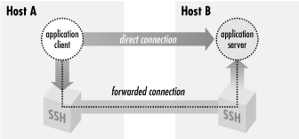
Port forwarding is a type of interaction between two applications, usually TCP/IP applications, that talk to each other using an SSH connection. SSH intercepts a service request from a client application on a host, creates an SSH session carrying the request to the other side of the SSH connection. The other side decrypts the request before sending it to the application server on the remote host. Port forwarding can be used to secure communications between applications that aren’t secured traditionally. They can also be used for communications that aren’t possible, for instance IT administrators block certain ports on hosts from external access with firewalls to improve security, with port forwarding it becomes possible to access those applications running on the remote machine. In a previous post we talked about a different type of forwarding called ssh-agent forwarding. This lets us create SSH connections from one computer, through a remote host, to a third remote host using public-key authentication without the need to have your private keys on the second remote host. Port forwarding is sometimes refereed to as “tunneling” because it provides a means for which you can secure TCP/IP connections through SSH.
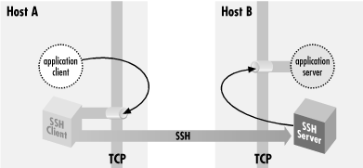

Local Port Forwarding
Suppose you have an IMAP server running on a remote host and you want to access the server using an email client on your home machine. Suppose also that the administrators of the remote host are super paranoid and they block all external access except only on port 80, 433 and 22. Unfortunately since IMAP runs on port 143 you can’t access it from your home. All you need to do is to tunnel through to the IMAP server using SSH. The command you need to run on your local machine is:
$ ssh -L2001:localhost:143 remote.net
Lets break down the above command. The -L switch specifies local forwarding; this essentially says the TCP client ( your email client) , is on your local machine. The 2001 represents the port on your local machine you want your email client to connect to. The localhost means the source sockets of the connection on the server appear to come from localhost. This means that the above command could be written as:
$ ssh -L2001:remote.net:143 remote.net
And the source packets would appear as coming from remote.net address. This maybe trivial in some TCP applications but, some servers are configured to do access control and block connections from the loopback address. Or it might be running on a multi-homed host, and have bound only a subset of the addresses the host has, possibly not including the loopback address. It’s generally better to use the first command. Finally 143 represents the port number the IMAP server is running on the remote server.
By default your SSH client only listens to connections from your local machine. That is it only accepts connections from applications running locally on your machine. Any attempt from external applications to attempt to connect over the wire to your SSH client will fail by default. To enable this you need to tweak the command above like so:
$ ssh -g -L2001:localhost:143 remote.net
The -g switch represents the GateWayPorts option in the client configuration file; if set it to yes then there’s no need for the -g option.
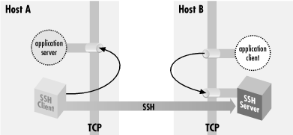

Remote Port Forwarding
An example of remote forwarding is, suppose we have an email client running on a remote server shell.isp.net and we want to access an IMAP server on another remote server remote.host.net with an SSH server installed then remote forwarding is the way to go in this case. The command to establish remote forwarding is:
$ ssh -R2001:localhost:143 remote.host.net
The syntax is similar to local port forwarding with the only difference being the -R switch instead of the -L in local port forwarding.
There are subtle differences between remote and local forwarding. The main difference being that in local forwarding the SSH client listens for communication from the application client and therefore usually resides on the same box as the application client. In remote forwarding the SSH server listens for communication from the application client, the SSH server and application client reside on the same host.

Dynamic Port Forwarding
You may ask is it possible to tunnel HTTP connections on port 80 to access an insecure website using local forwarding? The answer is yes but there are many restrictions that come with it. Such as, since the browser is running only on localhost then following an absolute URL such as “http://inseure/web/now.html” would not work since the browser only knows localhost also trying to proxy the request with your browser won’t work with any connections other than port 80. What would work for us in this case is dynamic port forwarding. SOCKS is a dynamic forwarding protocol, it is used by popular browsers such as tor to proxy requests and tunnel through to websites censored in certain countries and protect the users privacy. A SOCKS client connects via TCP, and indicates via the protocol the remote socket it wants to reach; the SOCKS server makes the connection, then gets out of the way, transparently passing data back and forth. The command to enable this with SSH is run like so:
$ ssh -D 1080 remote.host.net
When a user types an absolute URL into the browser including any port such as “http://myweb:1890”. The browser connects to SSH socks proxy on port 1080 and asks for connection to myweb:1890. The SSH client associates the browser’s connection with a new SSH session and then connects to the SSH server. The SSH client and server essentially get out of the way and the browser directly connects to the web server. Each new connection to a different web site gets assigned a new socket by SSH.

Conclusion
Port forwarding is a general TCP proxying feature that tunnels TCP connections through an SSH session. It is useful for securing protocols that may not be secure and tunneling through to TCP connections that may be blocked by firewalls. However there are some TCP protocols that may not work properly with port forwarding such as FTP. It so happens that FTP opens random ports on a client after authentication. This makes port forwarding unnecessarily complex. By and large majority of the TCP protocols do work with port forwarding.

How to Fix SSH Failed Permission Denied (publickey,gssapi-keyex,gssapi-with-mic)

Introduction
The SSH Permission denied error appears after permission-related settings are modified on the SSH server. Usual scenarios include a new package installation or the creation of new users.
In this tutorial, you will learn how to troubleshoot the SSH Permission denied error and reconnect to your SSH server.

Prerequisites
- SSH client on the local machine and SSH server on the remote system
- A user account to access the remote server (for password-based login)
- A user account with sudo or root privileges

What is Causing SSH Permission Denied (publickey,gssapi-keyex,gssapi-with-mic)?
The SSH Permission denied error appears when trying to SSH into a server:
Permission denied (publickey,gssapi-keyex,gssapi-with-mic)
Following the Permission denied statement, the bracket contains the attempted authentication methods that failed at the initiation of the connection. The error suggests that the public key is the issue, which is misleading.
One reason for the error may be sshd_config, the file that contains SSH server configuration. The other possibility is that the authorized_keys file has insufficient permissions. This file contains the list of public keys for the clients allowed to SSH into the server. Consequently, the system’s inability to read from the file results in the Permission denied error.

How to fix SSH Permission denied
Both solutions contain steps you need to perform on the server-side. Start by opening the terminal on your server and proceed with one of the solutions below.

Solution 1: Enable Password Authentication
If you want to use a password to access the SSH server, a solution for fixing the Permission denied error is to enable password login in the sshd_config file.
To do this, open the file in a text editor. This example uses the nano editor:
sudo nano /etc/ssh/sshd_config
In the file, find the PasswordAuthentication line and make sure it ends with yes.
Find the ChallengeResponseAuthentication option and disable it by adding no.
If lines are commented out, remove the hash sign # to uncomment them.
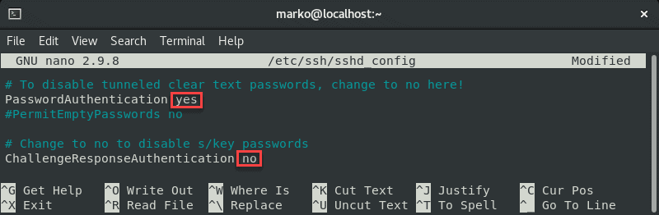
Save the file and exit.
Restart the SSH service by typing the following command:
sudo systemctl restart sshd

Solution 2: Change File System Permissions
Using the password-based login as the SSH authentication method is not recommended due to security concerns. Therefore, the following solution may be preferable since it troubleshoots the public key authentication method.
First, open the sshd_config file using a text editor:
sudo nano /etc/ssh/sshd_config
In the file, make sure the following options are set as follows:
PermitRootLogin no
PubkeyAuthentication yes
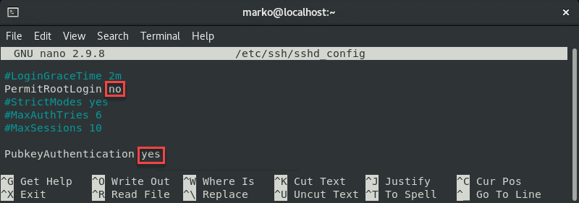
Note: The steps above are considered best security practices. If you need to use root login, set the relevant line to yes.
Comment out the GSSAPI-related options by adding the hash sign at the beginning of the line:
#GSSAPIAuthentication yes
#GSSAPICleanupCredentials no
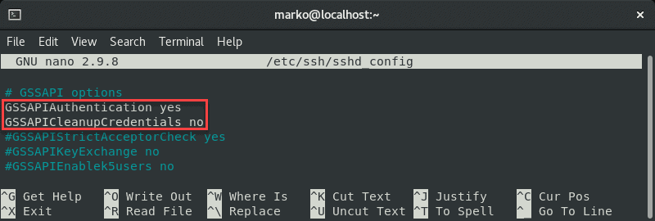
Also, make sure the UsePAM line is set to yes:
UsePAM yes
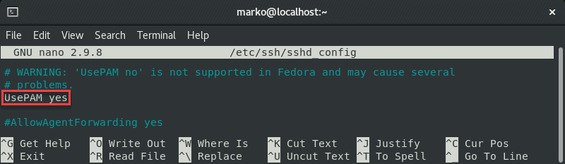
Save the file and restart the sshd service:
systemctl restart sshd
Now navigate to your home folder and check the permissions:
ls -ld

If your owner permissions are not set to read, write, and execute (drwx------), use the chmod command to change them:
chmod 0700 /home/[your-username]
Now go to the .ssh folder and recheck the permissions:
ls -ld
This directory should also have read, write, and execute permissions for the file owner. To enforce them, use chmod again:
chmod 0700 /home/your_home/.ssh
The .ssh folder contains the authorized_keys file. Check its permissions with:
ls –ld authorized_keys
The file owner should have read and write permissions. To set them, use:
chmod 0600 /home/[username]/.ssh/authorized_keys
Now try logging in with the key pair again. The output below shows a successful login attempt.
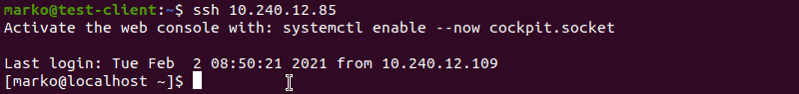
Note: For more information about Linux file permission, read the Linux File Permissions Tutorial.
Conclusion
This tutorial covered the steps necessary to troubleshoot the SSH Permission denied (publickey,gssapi-keyex,gssapi-with-mic) error. By completing the steps in the guide, you should fix the error and successfully SSH into your server.

How do I remove an SSH forwarded port

I used ssh -L 10002:192.168.0.30:10002 192.168.1.135 to establish port forwarding but now I need to remove it.
How do I do this?

If you are using Linux you can kill the process by:
ps aux | grep ssh
and then use
kill <id>
To kill the process.
If the kill command is not successfull you can try
kill -9 <id>

No. No. No. Please, please, please do not use kill -9 until after you've tried just kill. Many processes will have signal handlers which will clean up their use of resources, cleanly close connections and other pre-shutdown tasks. If you kill with -9, the process dies immediately without doing the cleanup. Killing without -9 will work most of the time.
– Doug Harris
Dec 23 '09 at 18:44
- 25
kill -9 without reason is like using a shotgun to kill a mosquito. :)
– Darren Hall
Dec 23 '09 at 21:24
- 4
I usually do a one liner pgrep ssh | xargs kill. Don't use -9 for nothing indeed

- 4
@GabLeRoux That assumes you only have a single ssh command, or that all the ssh commands you are running are fine to kill. This is hardly a good general assumption.
– tripleee
Apr 14 '16 at 9:11
- 3
@Avamander I connect to multiple ssh instances on multiple remote servers all the time, some of them without my direct active involvement. For example, Emacs Tramp mode opens an ssh connection behind the scenes when I visit a remote buffer. Some people use userspace filesystems which do something similar. It's not at all uncommon. In fact, I would assume single user, single ssh instance to be a minority fringe use case. If it works for you, good for you, but it's not good general advice.

When using ssh multiplexing, killing the ssh process is often undesirable (it kills all open connections with that host), and you cannot easily access the escape because "escape not available to multiplexed sessions". The right way is then to run the analogue of the forwarding command that you want to cancel, but adding -O cancel. For instance:
ssh -O cancel -L 10002:192.168.0.30:10002 192.168.1.135
This will disable this port forwarding without terminating the session. Again, this will only work if ssh multiplexing is in use for the connection to 192.168.1.135.

- 1
I'm so glad this exists and I found it, many thanks!
– galva
Sep 15 '17 at 11:39
- 6
This is a best solution. To kill master just run ssh -O exit 192.168.1.135.
– Tomilov Anatoliy
Sep 28 '17 at 9:27
- If you are not multiplexing sessions, see exhuma's excellent answer! (Thanks a3nm for catching my typo.)
– Alan De Smet
Jul 17 '18 at 20:25
- awesome! this should be the picked answer!
– Truong Nguyen
Jul 30 '18 at 18:15
Add a comment

27
How to cancel a forwarded port in an already running SSH session:
- Press ~+C (tilde + capital C)
- Type -KL 10002 (or whatever port number)
- Press Enter
You should see this:
ssh> -KL 10002
Canceled forwarding.

You can enter an interactive console by typing ~C (capital "C"). This lets you dynamically add and remove port forwardings (among a few other things).
This sequence has to come right after a carriage return/newline. So in doubt, just type Enter~C (in sequence).
If you don't see the characters appear on the console, you're doing it right :)
You should now see an ssh> prompt.
To remove the port, simply enter -KL 10002 followed by Enter (where 10002 is your forwarded port).
The inverse - adding a new forward - can be done like this (from start to finish):
Enter~C
ssh> -L 10002:192.168.0.30:10002
Enter

- 1
This is the right answer if you're not multiplexing connections. If you are, you'll be bounced with ~C escape not available to multiplexed sessions. If that's the case, see a3nm's excellent answer.
– Alan De Smet
Jul 16 '18 at 21:20

Add a comment

13
You could use the "escape-key" (usually ~) followed by C to get a cli to your connection. You can from there remove tunnels without taking down your connection.

